
ANNAMALAI UNIVERSITY

FACULTY OF ENGINEERING AND TECHNOLOGY

DEPARTMENT OF COMPUTER SCIENCE AND ENGINEERING

B. E. (COMPUTER SCIENCE AND ENGINEERING)
VII Semester
22CSCP706 – Embedded Systems and Internet of Things (IoT) Lab

Name : ............................................................................................................
Reg. No. : ............................................................................................................

ANNAMALAI UNIVERSITY

FACULTY OF ENGINEERING AND TECHNOLOGY

DEPARTMENT OF COMPUTER SCIENCE AND ENGINEERING

B. E. (COMPUTER SCIENCE AND ENGINEERING)
VII Semester
22CSCP706 – Embedded Systems and Internet of Things (IoT) Lab

22CSCP706 – Software Engineering Lab

Certified that this is a bonafide record of work done by Mr./ Ms. ....................................................................................................
Reg. No. ........................................................................ of B.E. (CSE) in the 22CSCP706 - EMBEDDED SYSTEMS AND INTERNET OF THINGS (IoT) LAB during the odd semester of the academic year 2026–27.

Staff-in-charge Internal Examiner

Place: Annamalai Nagar
Date :

External Examiner

CONTENTS
S. No. | Date | List of Experiments | Page No | Mark | Sign
01 |  | DISTANCE MEASUREMENT USING ARDUINO | 01
02 |  | IDENTIFYING MOISTURE CONTENT IN AGRICULTURAL LAND USING ARDUINO | 05
03 |  | MOTION DETECTION USING ARDUINO | 09
04 |  | IDENTIFYING ROOM TEMPERATURE AND HUMIDITY USING ARDUINO | 12
05 |  | COLOUR RECOGNITION USING ARDUINO | 16
06 |  | FIRE ALARM INDICATOR USING ARDUINO | 19
07 |  | SOUND DETECTION USING ARDUINO | 22
08 |  | INTERFACING FLEX SENSOR WITH ARDUINO | 25
09 |  | INTERFACING FORCE PRESSURE SENSOR WITH ARDUINO | 28
Total:
Average:

Annamalai University

Department of Computer Science and Engineering

VISION

To provide a congenial ambience for individuals to develop and blossom as academically superior, socially conscious and nationally responsible citizens.

MISSION

- Impart high quality computer knowledge to the students through a dynamic scholastic environment wherein they learn to develop technical, communication and leadership skills to bloom as a versatile professional.

- Develop life-long learning ability that allows them to be adaptive and responsive to the changes in career, society, technology, and environment.

- Build student community with high ethical standards to undertake innovative research and development in thrust areas of national and international needs.

- Expose the students to the emerging technological advancements for meeting the demands of the industry.

PROGRAMME EDUCATIONAL OBJECTIVES (PEOs)

PEO | PEO Statements
PEO1 | To equip the graduates with fundamental concepts and impart problem solving skills that will help them to pursue professional careers in Computer Science and Engineering.
PEO2 | To provide the graduates with the requisite knowledge to pursue higher education and carry out research in the field of Computer Science and Engineering.
PEO3 | To equip the graduates with the ability to acquire new skills in emerging areas of Computer Science and Engineering such as artificial intelligence, machine learning and data science and enable them to become successful professionals and entrepreneurs.
PEO4 | To ensure that the graduates exhibit high levels of ethical and moral behavior as computer engineers in addressing societal problems and providing sustainable development for the betterment of society.

PROGRAMME OUTCOMES (POs)

S. No. | Programme Outcomes
PO1 | Engineering Knowledge: Apply the knowledge of mathematics, science, engineering  fundamentals, and an engineering specialization to the solution of complex engineering problems.
PO2 | Problem Analysis: Identify, formulate, review research literature, and analyze complex engineering problems reaching substantiated conclusions using first principles  of mathematics, natural sciences and engineering sciences.
PO3 | Design/Development of Solutions: Design solutions for complex engineering problems and design system components or processes that meet the specified needs with appropriate consideration for the public health and safety, and the cultural,  societal, and environmental considerations.
PO4 | Conduct Investigations of Complex Problems: Use research-based knowledge and research methods including design of experiments, analysis and interpretation of data,  and synthesis of the information to provide valid conclusions.
PO5 | Modern Tool Usage: Create, select, and apply appropriate techniques, resources, and  modern engineering and IT tools including prediction and modeling to complex engineering activities with an understanding of the limitations.
PO6 | The Engineer and Society: Apply reasoning informed by the contextual knowledge to assess societal, health, safety, legal and cultural issues and the consequent  responsibilities relevant to the professional engineering practice.
PO7 | Environment and Sustainability: Understand the impact of the professional  engineering solutions in societal and environmental contexts, and demonstrate the knowledge of, and need for sustainable development.
PO8 | Ethics: Apply ethical principles and commit to professional ethics and responsibilities  and norms of the engineering practice.
PO9 | Individual and Team Work: Function effectively as an individual, and as a member  or leader in diverse teams, and in multidisciplinary settings.
PO10 | Communication: Communicate effectively on complex engineering activities with the engineering community and with society at large, such as, being able to comprehend and write effective reports and design documentation, make effective presentations, and  give and receive clear instructions.
PO11 | Project Management and Finance: Demonstrate knowledge and understanding of the engineering and management principles and apply these to one’s own work, as a member and leader in a team, to manage projects and in multidisciplinary  environments.
PO12 | Life-long Learning: Recognize the need for, and have the preparation and ability to engage in independent and lifelong learning in the broadest context of technological  change.

PROGRAMME SPECIFIC OUTCOMES (PSOs)

S. No. | Programme Specific Outcomes
PSO1 | Ability to investigate challenging problems in various domains and exhibit programming skills to build automation solutions.
PSO2 | Ability to apply the algorithms and computational techniques to construct robust and resilient computer systems and applications.
PSO3 | Ability to comprehend and implement the contemporary trends in industry and research environment paving the way for innovative solutions to existing and emerging problems.

Rubrics for Laboratory Examination (Internal/External)
(Internal: Two tests - 15 marks each, External: Two questions - 25 marks each)
Rubric | Poor | Average | Good | Excellent
Rubric | Up to (1/2) | Up to (2/4) | Up to (3/6) | Up to (5/8*)
Syntax and Logic Ability to understand, specify the data structures appropriate for the problem  domain | Program does not compile with typographical errors and incorrect logic leading to infinite loops. | Program compiles that signals major syntactic errors and logic shows severe errors. | Program compiles with minor syntactic errors and logic is mostly correct with occasional errors. | Program compiles with evidence of good syntactic understanding of the syntax and logic used.
Modularity Ability to decompose a problem into coherent and reusable functions, files, classes, or objects (as appropriate for the programming language  and platform). | Program is one big Function or is decomposed in ways that make little/no sense. | Program is decomposed into units of appropriate size, but they lack coherence or reusability.  Program contains unnecessary repetition. | Program is decomposed  into coherent units, but may still contain some unnecessary repetition. | Program is decomposed  into coherent and reusable units, and unnecessary repetition are eliminated.
Clarity and Completeness Ability to code formulae and algorithms that produce appropriate results. Ability to apply rigorous test case analysis to the problem domain. | Program does not produce appropriate results for most inputs.  Program shows little/no ability to apply different test cases. | Program approaches appropriate results for  most inputs, but contain some miscalculations. Program shows evidence of test case analysis, but missing significant test cases or mistaken some  test cases. | Program produces appropriate results for most inputs.  Program shows evidence of test case analysis that is mostly complete, but missed to handle all possible test cases. | Program produces appropriate results for all inputs tested.  Program shows evidence  of excellent test case analysis, and all possible cases are handled appropriately.
* 8 marks for syntax and logic, 8 marks for modularity, and 9 marks for Clarity and Completeness.

Rubric for CO3

Rubric for CO3 in Laboratory Courses
Rubric | Distribution of 10 Marks for CIE/SEE Evaluation Out of 40/60 Marks
Rubric | Up To 2.5 Marks | Up To 5 Marks | Up To 7.5 Marks | Up To 10 marks
Demonstrate | Poor listening and | Showed better | Demonstrated | Demonstrated
an ability to | communication | communication | good | excellent
listen and | skills. Failed to | skill by relating | communication | communication
answer the | relate the | the problem with | skills by relating | skills by relating
viva | programming | the programming | the problem with | the problem with
questions | skills needed for | skills acquired | the programming | the programming
related to | solving the | but the | skills acquired | skills acquired and
programming | problem. | description | with few errors. | have been
skills needed |  | showed serious |  | successful in
for solving |  | errors. |  | tailoring the
real-world |  |  |  | description.
problems in
Computer
Science and
Engineering.

Ex. No: 01 DISTANCE MEASUREMENT USING ARDUINO
Date:

AIM:
To measure the Distance of an Object using Ultrasonic Sensor HC–SR04.

LIST OF COMPONENTS:
- Arduino UNO
- Ultrasonic Sensor HC-SR04
- Solderless Breadboard
- Jumper Wires
- Buzzer
- 2x LEDs
- 2x Resistor 220Ω
WORKING DESCRIPTION:
Ultrasonic Sensor HC-SR04 is a sensor that can measure distance. It emits an ultrasound at 40 000 Hz (40 kHz) which travels through the air and if there is an object or obstacle on its path It will bounce back to the module. Considering the travel time and the speed of the sound you can calculate the distance. The configuration pin of HC-SR04 is VCC (1), TRIG (2), ECHO (3), and GND (4). The supply voltage of VCC is +5V and you can attach TRIG and ECHO pin to any Digital I/O in your Arduino Board.

In order to generate the ultrasound we need to set the Trigger Pin on a High State for 10 μs. That will send out an 8 cycle sonic burst which will travel at the speed sound and it will be received in the Echo Pin. The Echo Pin will output the time in microseconds the sound wave travelled.

For example, if the object is 20 cm away from the sensor, and the speed of the sound is 340 m/s or 0.034 cm/μs the sound wave will need to travel about 588 microseconds. But what you will get from the Echo pin will be double that number because the sound wave needs to travel forward and bounce backward. So in order to get the distance in cm we need to multiply the received travel time value from the echo pin by 0.034 and divide it by 2.

CONNECTION DIAGRAM:
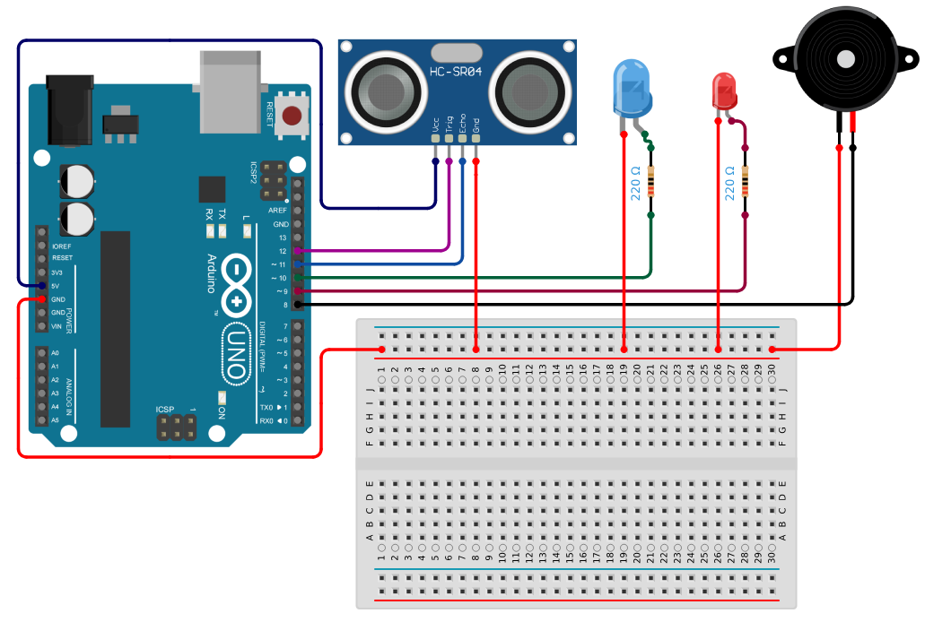

CONNECTIONS:
- Ultrasonic sensor to Arduino:
- Vcc to 5V
- Trig to pin 12
- Gnd to GND
- Echo to pin 11
- LED BLUE to Arduino:
- Negative to GND
- Positive to pin 10 and 220Ω Resistor
- LED RED to Arduino:
- Negative to GND
- Positive to pin 9 and 220Ω Resistor
- Buzzer to Arduino:
- Negative to GND
- Positive to pin 8

PROGRAM:
const int buzzer = 8;
const int redLED = 9;
const int blueLED = 10;
const int echoPin = 11;
const int trigPin = 12;

void setup() {
pinMode(trigPin, OUTPUT);
pinMode(echoPin, INPUT);
pinMode(blueLED, OUTPUT);
pinMode(redLED, OUTPUT);
pinMode(buzzer, OUTPUT);
Serial.begin(9600);
Serial.println("Distance Measurement Ready");
}

void loop() {
digitalWrite(trigPin, LOW);
delayMicroseconds(2);
digitalWrite(trigPin, HIGH);
delayMicroseconds(10);
digitalWrite(trigPin, LOW);

long duration = pulseIn(echoPin, HIGH, 30000);
int distance = duration * 0.034 / 2;

if (duration == 0) {
Serial.println("Out of range");
digitalWrite(blueLED, LOW);
digitalWrite(redLED, LOW);
noTone(buzzer);
} else {
Serial.print("Distance: "); Serial.print(distance); Serial.println(" cm");
digitalWrite(blueLED, LOW);
digitalWrite(redLED, LOW);
noTone(buzzer);

if (distance <= 10) {
Serial.println("VERY CLOSE!");
digitalWrite(blueLED, HIGH);
tone(buzzer, 1000);
delay(500);
noTone(buzzer);
} else if (distance <= 50) {
Serial.println("NEAR RANGE");
digitalWrite(redLED, HIGH);
} else {
Serial.println("FAR RANGE");
}
}
delay(100);
}

OUTPUT:
Distance Measurement Ready
Distance: 8 cm
VERY CLOSE!
Distance: 40 cm
NEAR RANGE
Distance: 100 cm
FAR RANGE

RESULT:
Thus, the Distance of an Object was measured using Arduino successfully.
Ex. No: 02 IDENTIFYING MOISTURE CONTENT IN AGRICULTURAL LAND USING ARDUINO
Date:

AIM:
To identify the Moisture content of soil in Agricultural Land using Soil Moisture Sensor.

LIST OF COMPONENTS:
- Arduino Uno
- Soil Moisture Sensor (Analog)
- Solderless Breadboard
- Buzzer
- 3 x LED
- 3 x 220Ω Resistors
- Jumper Wires
WORKING DESCRIPTION:
Soil moisture sensors measure the volumetric water content in soil. Since the direct gravimetric measurement of free-soil moisture requires removing, drying, and weighing of a sample, soil moisture sensors measure the volumetric water content indirectly by using some other property of the soil, such as electrical resistance, dielectric constant, or interaction with neutrons, as a proxy for the moisture content.

The relation between the measured property and soil moisture must be calibrated and may vary depending on environmental factors such as soil type, temperature, or electric conductivity. Reflected microwave radiation is affected by the soil moisture and is used for remote sensing in hydrology and agriculture. Portable probe instruments can be used by farmers or gardeners.

Soil moisture sensors typically refer to sensors that estimate volumetric water content. Another class of sensors measure another property of moisture in soils called water potential; these sensors are usually referred to as soil water potential sensors and include tensiometers and gypsum blocks.
There are different types of soil moisture sensor on the market, but their working principal are all similar. All of these sensors have at least three pins: VCC, GND, and AO. The AO pin changes according to the amount of moisture in the soil and increases as there is more water in the soil. Some models have an additional base called DO. If the moisture amount is less than the permissible amount (which can be changed by the potentiometer on the sensor) the DO pin will be “1”, otherwise will remain “0”.

In this Experiment, we have used the Soil Moisture Sensor. It has a detection length of 38mm and a working voltage of 2V-5V. It has a Fork-like design, which makes it easy to insert into the soil. The analog output voltage boosts along with the soil moisture level increases.

CONNECTION DIAGRAM:
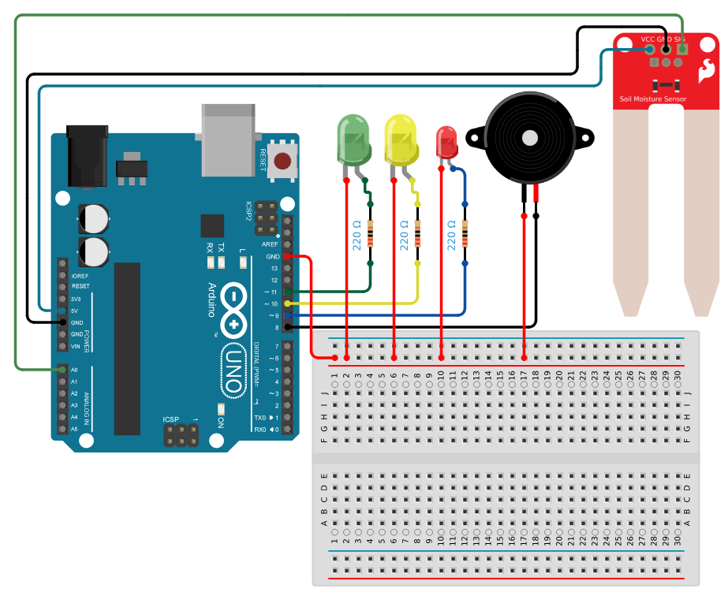

CONNECTIONS:
- Soil Moisture Sensor to Arduino:
- VCC to 5V
- GND to GND
- AO to A0
- Red LED to Arduino:
- Negative to GND
- Positive to pin 9 and 220Ω Resistor
- Yellow LED to Arduino:
- Negative to GND
- Positive to pin 10 and 220Ω Resistor
- Green LED to Arduino:
- Negative to GND
- Positive to pin 11 and 220Ω Resistor
- Buzzer to Arduino:
- Negative to GND
- Positive to pin 8

PROGRAM:
const int buzzer = 8;
const int ledDry = 9;
const int ledHumid = 10;
const int ledWet = 11;

void setup() {
pinMode(A0, INPUT);
pinMode(buzzer, OUTPUT);
pinMode(ledDry, OUTPUT);
pinMode(ledHumid, OUTPUT);
pinMode(ledWet, OUTPUT);
Serial.begin(9600);
Serial.println("Soil Moisture Monitoring Ready");
}

void loop() {
int sensorValue = analogRead(A0);

digitalWrite(ledDry, LOW);
digitalWrite(ledHumid, LOW);
digitalWrite(ledWet, LOW);
noTone(buzzer);

if (sensorValue >= 1000) {
Serial.println("Not in soil or disconnected");
}
else if (sensorValue >= 600) {
Serial.println("DRY SOIL");
digitalWrite(ledDry, HIGH);
tone(buzzer, 1000);
delay(1000);
noTone(buzzer);
}
else if (sensorValue >= 370) {
Serial.println("HUMID SOIL");
digitalWrite(ledHumid, HIGH);
}
else {
Serial.println("WATER SOIL");
digitalWrite(ledWet, HIGH);
}

Serial.println("----------");
delay(2000);
}

OUTPUT:
Soil Moisture Monitoring Ready
DRY SOIL
----------
HUMID SOIL
----------
WATER SOIL
----------

RESULT:
Thus, the Moisture content in Agricultural Land was measured using Arduino successfully.
Ex. No: 03 MOTION DETECTION USING ARDUINO
Date:

AIM:
To build a Motion Detection System using Arduino.

LIST OF COMPONENTS:
- Arduino Uno
- PIR Motion Sensor
- Buzzer
- LED (Red)
- 220Ω Resistor
- Jumper Wires
WORKING DESCRIPTION:
Home Automation is what makes us call our place a Smart Home. We can control all the appliances at our home using automation. The devices within the home automation system connect with each over a local network. When connected with the Internet, home devices are an important constituent of the Internet of Things. Mainly Home automation is to control or monitor signals from different appliances. Simply, this helps to make our lives easy.

An LDR (Light Dependent Resistor) is a component that has a (variable) resistance that changes with the light intensity that falls upon it. This allows them to be used in light sensing circuits. A photoresistor is made of a high resistance semiconductor. In the dark, a photoresistor can have a resistance as high as several megohms (MΩ), while in the light, a photoresistor can have a resistance as low as a few hundred ohms. If incident light on a photoresistor exceeds a certain frequency, photons absorbed by the semiconductor give bound electrons enough energy to jump into the conduction band.

The resulting free electrons (and their hole partners) conduct electricity, thereby lowering resistance. This example demonstrates the use of a LDR as a switch. Each time you cover the photocell, the LED (or whatever) is turned on or off.

PIR sensor detects a human being moving around within approximately 10m from the sensor. This is an average value, as the actual detection range is between 5m and 12m.PIR are fundamentally made of a pyro electric sensor, which can detect levels of infrared radiation. For numerous essential projects or items that need to discover when an individual has left or entered the area. PIR sensors are incredible, they are flat control and minimal effort, have a wide lens range, and are simple to interface with.

CONNECTION DIAGRAM:
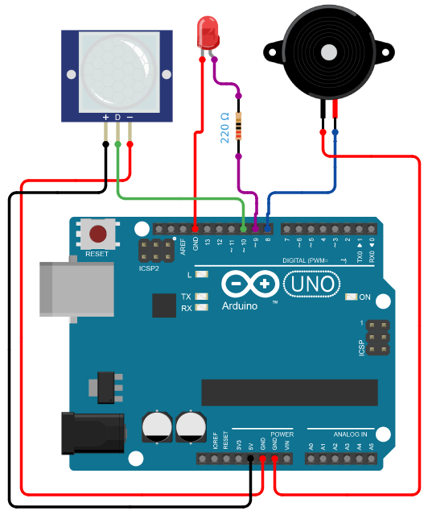

CONNECTIONS:
- PIR Sensor to Arduino:
- VCC to 5V
- GND to GND
- OUT to pin 10
- Red LED to Arduino:
- Negative to GND
- Positive to Pin 9 and 220Ω Resistor
- Buzzer to Arduino:
- Negative to GND
- Positive to pin 8

PROGRAM:
const int buzzer = 8;
const int led = 9;
const int pirPin = 10;
bool motionDetected = false;

void setup() {
Serial.begin(9600);
pinMode(pirPin, INPUT);
pinMode(led, OUTPUT);
pinMode(buzzer, OUTPUT);
Serial.println("Motion Detection Ready");
}

void loop() {
int motion = digitalRead(pirPin);
if (motion == HIGH) {
if (!motionDetected) {
Serial.println("Motion Detected");
digitalWrite(led, HIGH);
tone(buzzer, 1000);
delay(500);
noTone(buzzer);
motionDetected = true;
}
} else {
if (motionDetected) {
Serial.println("Motion stopped!");
digitalWrite(led, LOW);
motionDetected = false;
}
}
delay(100);
}

OUTPUT:
Motion Detection Ready
Motion Detected
Motion stopped!

RESULT:
Thus, the Motion detection System was built successfully using Arduino.
Ex. No: 04 IDENTIFYING ROOM TEMPERATURE AND HUMIDITY USING ARDUINO
Date:

AIM:
To identify the Room Temperature and Humidity using DHT11 Sensor.

LIST OF COMPONENTS:
- Arduino Uno
- DHT11 Sensor
- Solderless Breadboard
- Buzzer
- 3 x LED
- 3 x 220Ω Resistors
- Jumper Wires
WORKING DESCRIPTION:
DHT11 is a low-cost digital sensor for sensing temperature and humidity. This sensor can be easily interfaced with any micro-controller such as Arduino, Raspberry Pi etc. to measure humidity and temperature instantaneously. DHT11 humidity and temperature sensor is available as a sensor and as a module. The difference between this sensor and module is the pull-up resistor and a power-on LED. DHT11 is a relative humidity sensor. To measure the surrounding air this sensor uses a thermistor and a capacitive humidity sensor.
WORKING PRINCIPLE OF DHT11 SENSOR:
DHT11 sensor consists of a capacitive humidity sensing element and a thermistor for sensing temperature. The humidity sensing capacitor has two electrodes with a moisture holding substrate as a dielectric between them. Change in the capacitance value occurs with the change in humidity levels. The IC measure, process this changed resistance values and change them into digital form.

For measuring temperature this sensor uses a Negative Temperature coefficient thermistor, which causes a decrease in its resistance value with increase in temperature. To get larger resistance value even for the smallest change in temperature, this sensor is usually made up of semiconductor ceramics or polymers.

The temperature range of DHT11 is from 0 to 50 degree Celsius with a 2-degree accuracy. Humidity range of this sensor is from 20 to 80% with 5% accuracy. The sampling rate of this sensor is 1Hz .i.e. it gives one reading for every second. DHT11 is small in size with operating voltage from 3 to 5 volts. The maximum current used while measuring is 2.5mA.

CONNECTION DIAGRAM:
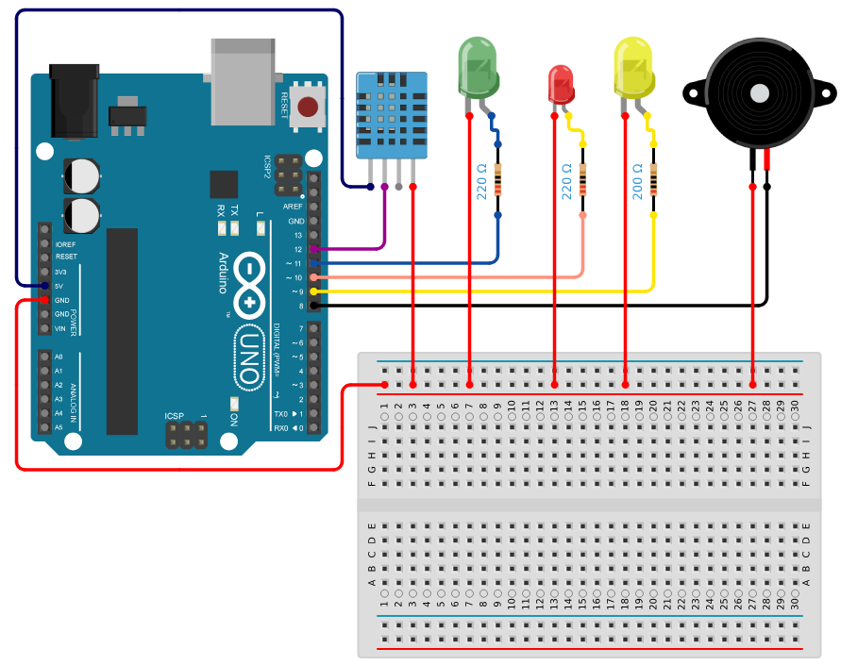

CONNECTIONS:
- DHT11 Sensor to Arduino:
- VCC to 5V
- GND to GND
- Data to pin 12
- Error LED to Arduino:
- Negative to GND
- Positive to pin 9 and 220Ω Resistor
- High Temp LED to Arduino:
- Negative to GND
- Positive to pin 10 and 220Ω Resistor
- Normal LED to Arduino:
- Negative to GND
- Positive to pin 11 and 220Ω Resistor
- Buzzer to Arduino:
- Negative to GND
- Positive to pin 8

PROGRAM:
#include "DHT.h"
#define DHTPIN 12
#define DHTTYPE DHT11
DHT dht(DHTPIN, DHTTYPE);

const int buzzer = 8;
const int ledError = 9;
const int ledHighTemp = 10;
const int ledNormal = 11;

void setup() {
Serial.begin(9600);
dht.begin();
pinMode(buzzer, OUTPUT);
pinMode(ledError, OUTPUT);
pinMode(ledHighTemp, OUTPUT);
pinMode(ledNormal, OUTPUT);
Serial.println("Climate Monitoring Ready");
}

void loop() {
digitalWrite(ledError, LOW);
digitalWrite(ledHighTemp, LOW);
digitalWrite(ledNormal, LOW);
noTone(buzzer);

delay(2000);
float h = dht.readHumidity();
float t = dht.readTemperature();

if (isnan(h) || isnan(t)) {
Serial.println("Sensor Error!");
digitalWrite(ledError, HIGH);
delay(1000);
return;
}

Serial.print("Humidity: "); Serial.print(h);
Serial.print("% Temp: "); Serial.print(t); Serial.println("°C");

if (t > 29) {
Serial.println("HIGH TEMP ALERT!");
digitalWrite(ledHighTemp, HIGH);
tone(buzzer, 1000);
delay(500);
noTone(buzzer);
} else {
Serial.println("Normal Climate");
digitalWrite(ledNormal, HIGH);
}
delay(1000);
}

OUTPUT:
Climate Monitoring Ready
Humidity: 45% Temp: 28.00°C
Normal Climate
Humidity: 45% Temp: 28.00°C
Normal Climate
Humidity: 45% Temp: 28.00°C
Normal Climate
Humidity: 50% Temp: 31.00°C
HIGH TEMP ALERT!
Humidity: 50% Temp: 31.00°C
HIGH TEMP ALERT!
Humidity: 50% Temp: 31.00°C
HIGH TEMP ALERT!

RESULT:
Thus, the Room Temperature and Humidity was measured successfully using DHT11 sensor.
Ex. No: 05 COLOUR RECOGNITION USING ARDUINO
Date:

AIM:
To identify the different colours using Colour Recognition Sensor.

LIST OF COMPONENTS:
- Arduino Uno
- TCS3200 Color Sensor
- Jumper Wires
WORKING DESCRIPTION:
Colour sensors provide more reliable solutions to complex automation challenges. They are used in various industries including the food and beverage, automotive and manufacturing industries for purposes such as detecting material, detecting colour marks on parts, verifying steps in the manufacturing process and so on.
WORKING PRINCIPLE OF COLOUR RECOGNITION SENSOR:
The TCS230 Color sensor (also branded as the TCS3200) is quite popular, inexpensive and easy to use. At the heart of the module is an inexpensive RGB sensor chip from Texas Advanced Optoelectronic Solutions – TCS230. The TCS230 Color Sensor is a complete colour detector that can detect and measure an almost infinite range of visible colours.

The sensor itself can be seen at the centre of the module, surrounded by the four white LEDs. The LEDs light up when the module is powered up and are used to illuminate the object being sensed. Due to these LEDs, the sensor can also work in complete darkness to determine the colour or brightness of the object. The TCS230 operates on a supply voltage of 2.7 to 5.5 volts and provides TTL logic- level outputs.

The TCS230 detects colour with the help of an 8 x 8 array of photodiodes, of which sixteen photodiodes have red filters, 16 photodiodes have green filters, 16 photodiodes have blue filters, and remaining 16 photodiodes are clear with no filters.

CONNECTION DIAGRAM:
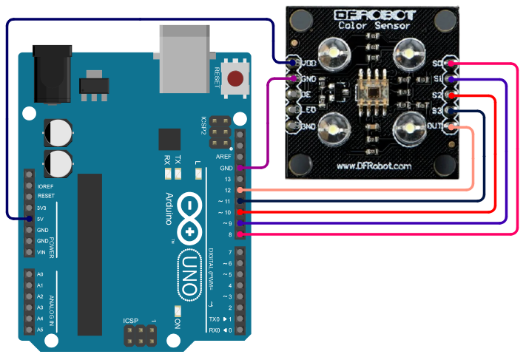

CONNECTIONS:
- TCS3200 Sensor to Arduino:
- VCC to 5V
- GND to GND
- S0 to pin 8
- S1 to pin 9
- S2 to pin 10
- S3 to pin 11
- OUT to pin 12

PROGRAM:
const int s0 = 8, s1 = 9, s2 = 10, s3 = 11, out = 12;

void setup() {
pinMode(s0, OUTPUT); pinMode(s1, OUTPUT);
pinMode(s2, OUTPUT); pinMode(s3, OUTPUT);
pinMode(out, INPUT);
Serial.begin(9600);
digitalWrite(s0, HIGH); digitalWrite(s1, HIGH);
Serial.println("Color Recognition Ready");
}

void loop() {
digitalWrite(s2, LOW); digitalWrite(s3, LOW);
Serial.print("Red = "); readColor();
digitalWrite(s2, LOW); digitalWrite(s3, HIGH);
Serial.print("Blue = "); readColor();
digitalWrite(s2, HIGH); digitalWrite(s3, HIGH);
Serial.print("Green = "); readColor();
Serial.println(); delay(2000);
}

void readColor() {
long d = pulseIn(out, LOW, 30000);
if (d == 0) Serial.print("NoSignal");
else Serial.print(d);
Serial.print("\t"); delay(1000);
}

OUTPUT:
Color Recognition Ready
Red = 1250 Blue = 980 Green = 1100
Red = 1250 Blue = 980 Green = 1100
Red = 600 Blue = 1500 Green = 700
Red = 600 Blue = 1500 Green = 700

RESULT:
Thus, the Colour Recognition Sensor has been interfaced with Arduino successfully.
Ex. No: 06 FIRE ALARM INDICATOR USING ARDUINO
Date:

AIM:
To develop a Fire Alarm Indicator using the Flame sensor.

LIST OF COMPONENTS:
- Arduino Uno
- Flame Sensor (Analog)
- Solderless Breadboard
- Buzzer
- 3 x LED
- 3 x 220Ω Resistors
- Jumper Wires
WORKING DESCRIPTION:
A flame-sensor is one kind of detector which is mainly designed for detecting as well as responding to the occurrence of a fire or flame. The flame detection response can depend on its fitting. It includes an alarm system, a natural gas line, propane & a fire suppression system. This sensor is used in industrial boilers. The main function of this is to give authentication whether the boiler is properly working or not. The response of these sensors is faster as well as more accurate compare with a heat/smoke detector because of its mechanism while detecting the flame.
WORKING PRINCIPLE:
This sensor/detector can be built with an electronic circuit using a receiver like electromagnetic radiation. This sensor uses the infrared flame flash method, which allows the sensor to work through a coating of oil, dust, water vapor, otherwise ice.

CONNECTION DIAGRAM:
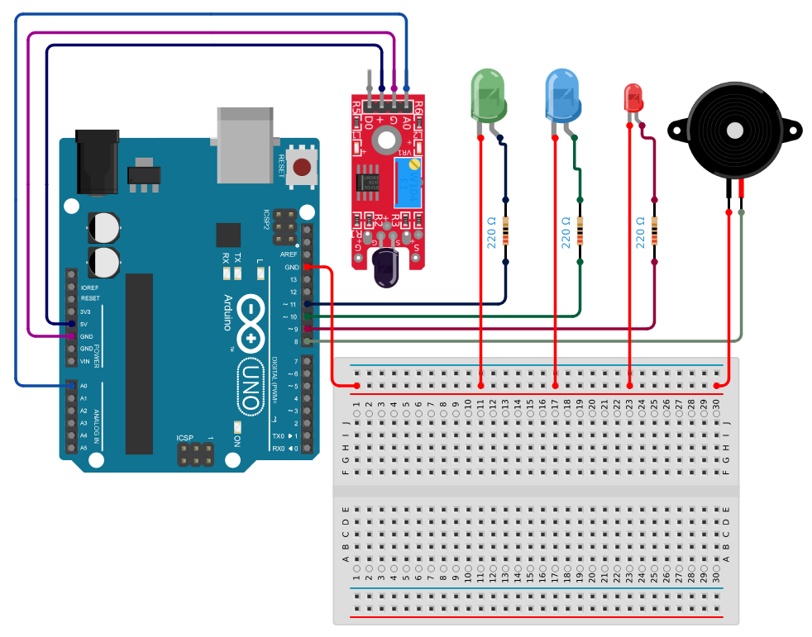

CONNECTIONS:
- Flame Sensor to Arduino:
- VCC to 5V
- GND to GND
- AO to A0
- Close Fire LED to Arduino:
- Negative to GND
- Positive to pin 9 and 220Ω Resistor
- Distant Fire LED to Arduino:
- Negative to GND
- Positive to pin 10 and 220Ω Resistor
- No Fire LED to Arduino:
- Negative to GND
- Positive to pin 11 and 220Ω Resistor
- Buzzer to Arduino:
- Negative to GND
- Positive to pin 8

PROGRAM:
const int buzzer = 8;
const int ledClose = 9;
const int ledDistant = 10;
const int ledNone = 11;

void setup() {
Serial.begin(9600);
pinMode(buzzer, OUTPUT);
pinMode(ledClose, OUTPUT);
pinMode(ledDistant, OUTPUT);
pinMode(ledNone, OUTPUT);
Serial.println("Fire Alarm Ready");
}

void loop() {
int flame = analogRead(A0);

digitalWrite(ledClose, LOW);
digitalWrite(ledDistant, LOW);
digitalWrite(ledNone, LOW);
noTone(buzzer);

if (flame < 200) {
Serial.println("Close Fire");
digitalWrite(ledClose, HIGH);
tone(buzzer, 1000);
delay(500);
noTone(buzzer);
}
else if (flame < 500) {
Serial.println("** Distant Fire **");
digitalWrite(ledDistant, HIGH);
}
else {
Serial.println("No Fire");
digitalWrite(ledNone, HIGH);
}

delay(500);
}

OUTPUT:
Fire Alarm Ready
No Fire
No Fire
** Distant Fire **
Close Fire

RESULT:
Thus, the Fire Alarm Indicator was successfully implemented using Flame Sensor.
Ex. No: 07 SOUND DETECTION USING ARDUINO
Date:

AIM:
To develop a Sound Detection System using the Sound Sensor.

LIST OF COMPONENTS:
- Arduino Uno
- KY-038 Sound Sensor
- LED
- 220Ω Resistor
- Jumper Wires
WORKING DESCRIPTION:
The microphone sound sensor, as the name says, detects sound. It gives a measurement of how loud a sound is. There are a wide variety of these sensors. In the figure below you can see the most common used with the Arduino.
In this example, a microphone sensor will detect the sound intensity of your surroundings and will light up an LED if the sound intensity is above a certain threshold.

CONNECTION DIAGRAM:
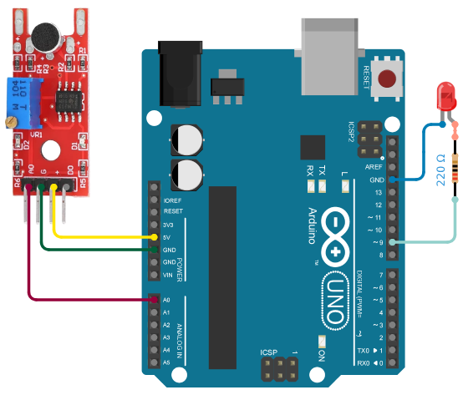

CONNECTIONS:
- Sound Sensor to Arduino:
- VCC to 5V
- GND to GND
- AO to A0
- LED to Arduino:
- Negative to GND
- Positive to pin 9 and 220Ω Resistor

PROGRAM:
const int soundPin = A0;
const int ledPin = 9;
const int threshold = 600;

void setup() {
pinMode(ledPin, OUTPUT);
Serial.begin(9600);
Serial.println("Sound Detection Ready");
}

void loop() {
int value = analogRead(soundPin);
Serial.print("Sound Level: "); Serial.println(value);

if (value > threshold) {
digitalWrite(ledPin, HIGH);
delay(200);
} else {
digitalWrite(ledPin, LOW);
}
delay(100);
}

OUTPUT:
Sound Detection Ready
Sound Level: 320
Sound Level: 450
Sound Level: 330
Sound Level: 500
Sound Level: 850 ← Clap!
Sound Level: 600
Sound Level: 320

RESULT:
Thus, the Sound Detection System using Arduino was implemented successfully.
Ex. No: 08 INTERFACING FLEX SENSOR WITH ARDUINO
Date:

AIM:
To interface a Flex Sensor with Arduino board.

LIST OF COMPONENTS:
- Arduino Uno
- Flex Sensor
- LED
- 10kΩ Resistor
- 220Ω Resistor
- Jumper Wires
WORKING DESCRIPTION:
A flex sensor is a kind of sensor which is used to measure the amount of defection otherwise bending. The carbon surface is arranged on a plastic strip as this strip is turned aside then the sensor’s resistance will be changed. Thus, it is also named a bend sensor.

A flex-sensor could be used to check a door or window is opened or not. This sensor can be arranged at the edge of the door and once the door opens then this sensor also gets flexed. When the sensor bends then its parameters automatically change which can be designed to give an alert.

This sensor works on the bending strip principle which means whenever the strip is twisted then its resistance will be changed. This can be measured with the help of any controller. This sensor works similar to a variable resistance because when it twists then the resistance will be changed. The resistance change can depend on the linearity of the surface because the resistance will be dissimilar when it is level.

Flex sensors are designed to flex in only one direction – away from ink (as shown in the figure). Bending the sensor in another direction may damage it.

When the sensor is straight, this resistance is about 25k. When the sensor is bent, conductive layer is stretched, resulting in reduced cross section (imagine stretching a rubber band). This reduced cross section results in an increased resistance. At 90° angle, this resistance is about 100KΩ.

When the sensor is straightened again, the resistance returns to its original value. By measuring the resistance, we can determine how much the sensor is bent.

CONNECTION DIAGRAM:
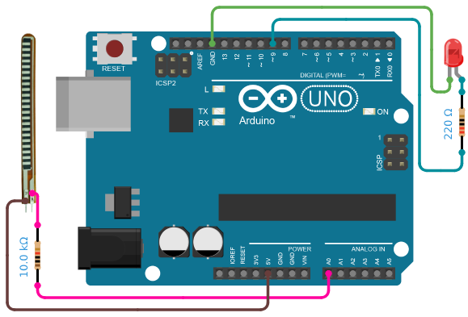

CONNECTIONS:
- Flex Sensor to Arduino:
- Pin 1 to 5V
- Pin 2 to A0 and 10kΩ Resistor
- 10kΩ Resistor:
- One end to A0 and Flex Pin 2
- Other end to GND
- LED to Arduino:
- Negative to GND
- Positive to pin 9 and 220Ω Resistor

PROGRAM:
const int flexPin = A0;
const int ledPin = 9;

void setup() {
pinMode(ledPin, OUTPUT);
Serial.begin(9600);
Serial.println("Flex Sensor Ready");
}

void loop() {
int value = analogRead(flexPin);
Serial.print("Flex Value: "); Serial.println(value);

if (value > 890) {
digitalWrite(ledPin, HIGH);
} else {
digitalWrite(ledPin, LOW);
}
delay(100);
}

OUTPUT:
Flex Sensor Ready
Flex Value: 520 ← Straight
Flex Value: 621
Flex Value: 679
Flex Value: 758
Flex Value: 865
Flex Value: 920 ← Bent → LED ON
Flex Value: 689
Flex Value: 564

RESULT:
Thus, the Flex Sensor was interfaced with Arduino successfully.
Ex. No: 09 INTERFACING FORCE PRESSURE SENSOR WITH ARDUINO
Date:

AIM:
To interface a force pressure sensor with Arduino board.

LIST OF COMPONENTS:
- Arduino Uno
- FSR
- 10kΩ Resistor
- Jumper Wires
WORKING DESCRIPTION:
The working principle of a force sensor is that it responds to the applied force, as well as converts the value to a measurable quantity. Most force sensors are created with the use of force-sensing resistors. Such sensors consist of electrodes and sensing film.

Force-sensing resistors are based on contact resistance. These contain a conductive polymer film, which changes its resistance in a predictable way once force is applied on the surface.

In road traffic, force measurement plays an essential role. For instance, force sensors are being used in trucks. This means that the axle load may be determined precisely to enable effective and fast monitoring. Different force sensors are in use in automobiles. For instance, force sensors in the area of trailer couplings offer the possibility to know the trailer’s load, and to determine static information in relation to dynamic driving behavior on the road.

CONNECTION DIAGRAM:
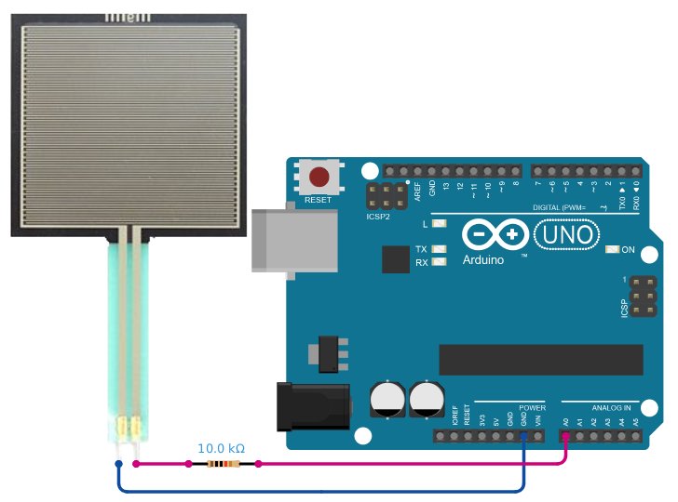

CONNECTIONS:
- FSR to Arduino:
- Pin 1 to 5V
- Pin 2 to A0 and 10kΩ resistor
- 10kΩ Resistor:
- One end to A0 and FSR Pin 2
- Other end to GND

PROGRAM:
const int fsrPin = A0;

void setup() {
Serial.begin(9600);
Serial.println("Force Sensor Ready");
}

void loop() {
int reading = analogRead(fsrPin);
Serial.print("Force Reading: "); Serial.print(reading);

if (reading < 10) Serial.println(" → No Pressure");
else if (reading < 200) Serial.println(" → Light Touch");
else if (reading < 500) Serial.println(" → Light Pressure");
else if (reading < 800) Serial.println(" → Medium Pressure");
else Serial.println(" → Heavy Pressure");

delay(200);
}

OUTPUT:
Force Sensor Ready
Force Reading: 5 → No Pressure
Force Reading: 150 → Light Touch
Force Reading: 600 → Medium Pressure
Force Reading: 950 → Heavy Pressure

RESULT:
Thus, the Force Pressure Sensor was interfaced with Arduino successfully.

